Table of Contents

Introduction 1

Origin of the Report 1

Objectives 1

Methodology 1

Limitations 1

Company Overview 2

FANUC Corporation 2

Industry analysis 3

Pestle Analysis 3

Porter’s Five Forces 6

SWOT Analysis of FANUC CORP.Corporation 8

Business risk 10

Financial Risk FANUC 12

Ratio Analysis 12

Interest Coverage Ratio (TIE) 12

Bankruptcy Risk 14

Altman’s Z-score 14

Altman Z score model is a combination of 5 weighted business ratios that is useful to determine the probability of financial distress. 14

Problem Statement 16

Valuation Analysis 16

Assumptions 16

The WACC calculation 17

Valuation of FANUC 17

Simulation Analysis and sensitivity analysis of FANUC 18

# Introduction

FANUC is a strong technology company from the golden times of Japanese economy. Old school system of corporate governance served its purpose for a long period of time. Its secretive style didn’t create any problem, rather actually played to its advantage until the adverse demographic-socio-economic change made situation worse. The company is actually in mature stage. But strong future performance is highly likely because the domain of the company is less crowded. Being number one also helps. The company has a lot of money in hand for risky investments given their technological superiority in the most difficult field, they can expand their business in any less advance but more popular segments. For example, heavy machinery and building equipments that may become more use full with numerical control and artificial intelligence. There is a vast realm of possibility to explore and we believe that FANUC has both the technical capability and financial solvency to do it. It’s time to begin a new journey because to prevail successfully in this capitalistic economy, one must be proactive.

# Origin of the Report

The importance of gathering practical knowledge during the study life along with the theoretical knowledge has got same or sometime even more importance. Again practical knowledge is more necessary for the course “Cases in Financial Decision Making”, code F-506. For this reason, as a partial requirement of our M.B.A. program for the above mentioned course we are told to choose a topic on our own and then prepare and submit the report to the honorable course teacher.

# Objectives

The objectives of this report are:

-To fulfill the partial requirement of MBA degree.

-To be able to use theoretical knowledge into practice to determine the optimum corporate restructuring.

-To develop our skill in using analytical tools and techniques.

-To develop our interpersonal views and concept through sharing among every member of the group that is reflected in this report.

# Methodology

The information for the report was collected from secondary sources that are from the case and also from different published articles, books, prospectus and journals. The basic method that is used to analyze the data is quantitative analysis based on these data.

# Limitations

-A lot of information regarding industry, economy, and company were required.

-Inefficiency in some field of analysis.

-Due to our lack of practical knowledge our analysis may not be a highly efficient one.

# Company Overview

## FANUC Corporation

Dr. Seiuemon Inaba, FANUC’s visionary founder and father of the current CEO Dr. Y. Inaba, joined Fuji Tsushinki Manufacturing Corporation (later named Fujitsu) in 1946, and developed the first numerical control (NC) system in 1956. The NC business grew quickly and became very profitable as costs came down. In 1972, Fujitsu spun off the NC business into a new company called Fujitsu FANUC Ltd. (FANUC stood for Fuji Automatic NUmerical Control) with Seiuemon Inaba as its president.

In 1995, at age 70, Seiuemon Inaba stepped down as president to become chairman and then honorary chairman of FANUC. His son, Dr. Y. Inaba, became the president in 2003. Despite the change in leadership, Seiuemon Inaba continued to be actively involved with important business decisions. In 2013, he relinquished all control and involvement with the firm leaving his son in full control.

FANUC’s operations were divided into three divisions. The **Factory Automation** (FA) **Division** developed computer numerical control (CNC) systems for machine tools—it was the “gold standard” for machine tool software. The **Robot Division** produced industrial robots that could perform complex tasks in place of humans. Finally, the **RoboMachine Division** produced high-speed precision machining centers to make such things as aluminum mobile phone cases. The FA Division had a global market share of almost 60%, while the other two divisions also had leading market shares globally.

The company was known for being secretive and indifferent to analysts and investors. Email exchanges outside the company were restricted, and even customers were required to use a special encrypted email system.The company rarely held meetings with investors and analysts, and disclosed little information to the public beyond what was required. In fact, the Securities Analysts Association of Japan ranked FANUC last out of 251 companies in its annual corporate disclosure index in 2014.

**Reform proposals**

Japan is subject to a lot of criticism for its corporate governance style. But recently things have gone more problematic. To rejuvenate the economy prime minister shinzo Abe has taken a few steps.

The first pillar of the Abe’s strategy (the pillars were known as “arrows”) was the use of aggressive monetary policy to overcome deflation. Abe announced an inflation target of 2% which would be achieved through both quantitative and qualitative easing. Towards that end, the BOJ promised to double the country’s monetary base by December 2014. The second arrow was fiscal stimulus. In January 2013, the Abe administration proposed an additional ¥10 trillion of government spending. To pay for this spending, the administration announced an increase in the consumption tax from 5% to 8% starting in April 2014. Knowing that a tax increase would likely cause consumer spending to fall, the administration proposed an additional ¥5.5 trillion of government spending in December 2013 (in addition to the original ¥10 trillion). The third arrow was a growth strategy designed to increase private investment and achieve real GDP growth of 2% per year.

The administration announced the details of the third arrow (“Japan Revitalization Strategy—Japan is Back”) in June 2013. The primary goal was to restore confidence in the economy by implementing regulatory reform, increasing labor force participation, especially by women, and reviving Japan as a technology-driven economy.

The challenge of maintaining national wealth in a country with a rapidly aging population and a shrinking workforce. The only solution was for companies to “enhance their earning power and deliver sustained value creation.” To do so, Japanese companies had to increase their capital efficiency and improve their communications with shareholders. In terms of specific recommendations, the report said Japanese companies should generate a minimum ROE of at least 8% (or at least greater than their costs of capital), and warned that “the capital markets will naturally eliminate companies that fail (to achieve ROE’s in excess of their cost of capital).”

**Reassessing the Company’s Financial and Governance Policies**

The company is profitable but its operating principles seem unrealistic. It holds a lot of cash, probably because it fears an upcoming shock. It has no debt. To add to that the company does not give importance to shareholders current wealth maximization in the form of increasing ROE rather thinks about lasting for hundred years with low return on equity.

All these are recently being reassessed as Japanese govt. push for a better Corporate governance policy.

# Industry analysis

## Pestle Analysis

The PESTLE analysis model is a strategic management tool that identifies the various external factors relevant to firms, based on the conditions of their remote or macro-environment. In the FANUC Corp.Corporation’s case, these factors determine the company’s growth path. The global market presents challenges that threaten FANUC Corp.Corporation while creating opportunities for improvement. Thus, strategies and reforms based on the elements of the PESTLE analysis model can boost FANUC Corp.Corporation’s long-term growth.

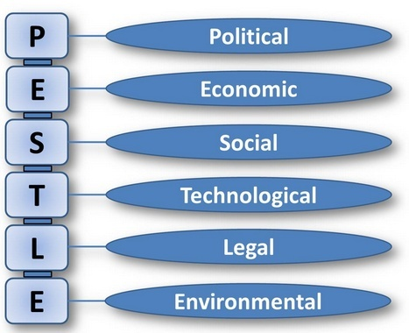

**ECONOMIC**

Japan’s postwar economy can be divided into three sub-periods: a high-growth period from 1955 to 1972, a stable-growth period from 1973 to 1989, and a no-growth period from 1990 to 2014. During the high-growth period, GDP growth averaged over 9% per year as Japan rebuilt its industrial base and became the second-largest economy in the world. Growth slowed considerably to an average of 3% in the 1970s due in large part to an appreciating yen that hurt the export-driven economy and two oil shocks that slowed growth because of the country’s dependence on foreign oil. Stock prices crashed in 1990 and land prices crashed the following year, ushering in a no-growth period known as the “lost decade.” Over the next 20 years, economic growth stalled, consumer spending declined, unemployment rose, and consumer prices fell. At the end of 2014, the Nikkei 225 Index was still 50% below its all-time high, achieved some 25 years earlier. So, the economic condition is not very healthy at all.

**SOCIAL**

Japan’s economic challenges were complicated by a series of important demographic changes. First, the country’s population was shrinking due to low fertility and birth rates: after peaking at 128.1 million people in 2008, the population was expected fall to 117 million by 2030. Second, and relatedly, the civilian workforce (people ages 16 to 65 who were able to work) was also falling: after peaking in 1997 at 65.6 million workers, the number of workers was expected to fall by 10% by 2030. And finally, due to a steady increase in life expectancy, the country had an aging population: by 2030, 30% of the population would be over age 65, compared to only 21% in 2005. Because of these factors, Japan needed to boost productivity to support its aging population with fewer and fewer workers.

**TECHNOLOGICAL**

Japan is becoming one of the frontrunners in industrial technology, which mean that prominent science and technology policy researchers all over the world now pay more attention to Japan. The government has channeled research and development efforts, directed financing and protected market for business. Hence, talk has begun of a new 'techno economic' paradigm emerging in Japan from a pattern of industrial catch up and efforts to build a position in advancing technologies. Japan is a leading country in areas such as transport, infrastructure, and intelligence transport system and in water management.So,they can go for technology based products.

**LEGAL**

The Civil Code of Japan was created in 1896 and was heavily influenced by the German and French Civil codes and emphasized law and order over individual freedom. Within the legislative process there is a separation of three branches: legislative, executive and judiciary. The highest organ of state power and the sole law-making body of the state is the Diet, or parliament, made up of the House of Representatives and the House of Councilors. The executive power is vested in the Cabinet, through which the Prime Minister works. The whole judicial power is vested in the Supreme Court and inferior courts established by law. It fascinates doing business there.

**ENVIRONMENTAL**

Japan's environmental policy has reflected a tenuous balance between economic development and environmental protection. Current environmental policy and regulations are a consequence of a number of environmental disasters in the 50s and 60s.In the 2006 Ministry of Environment report showed major issued of global warming, conservation of the atmospheric environment, waste management, measure for chemicals substances, conservation and participation in the international cooperation However, Japan has one of the most sophisticated recycling systems in the world. Due to land scarcity in Japan up to 80% of garbage is incinerated and there are 44 garbage categories for recycling and incineration. It has also passed a law requiring retailers and manufacturers to take back used appliance and to publicize their recycling, in an attempt to create a closed loop economy. You have to keep necessary arrangements to keep the environment safe.

## Porter’s Five Forces

The last of [Porter’s five forces](https://www.cleverism.com/porters-five-forces-model-strategy-framework/) deals with firms competing within the industry and the extent to which they exert pressure on each other. This pressure leads to limits on the profit potential of these firms. In industries where there is fierce competitive rivalry to contend with, there are efforts to gain the most profit and market share from each other. This battle can end up decreasing the potential for profit for all of the companies.

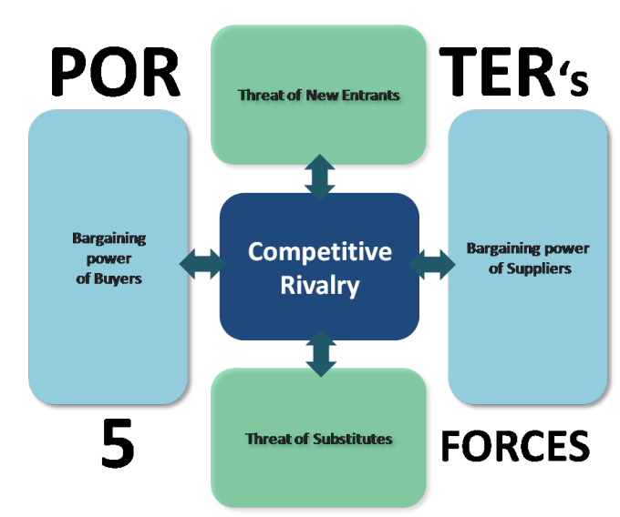

A Five Forces analysis of FANUC CORP.reveals that the company must prioritize the impacts of competition and the influences of consumers and substitutes. These forces shape its strategies. They are stated below--------------

**Competitive Rivalry-High**

This component of the Five Forces analysis shows that there are other factors that determine the influence of competitive rivalry. The following are the most notable external factors that create the strong force of competition against FANUC:

* High aggressiveness of firms
* Low switching costs
* High number of firms

**Bargaining Power of Customers/Buyers-High**

Consumers are among the top priorities in FANUC’s mission statement. The effects of customers on the firm’s industry environment are determined in this component of the Five Forces analysis. The external factors that lead to the strong bargaining power of FANUC’s consumers/buyers are as follows:

* Low switching costs
* High access to product information
* High availability of substitutes

**Bargaining Power of Suppliers-Weak**

FANUC Corp.must maintain profitable relationships with suppliers. This component of the Five Forces analysis covers the impact of suppliers on the company’s industry environment. The weak bargaining power of FANUC’s suppliers is based on the following external factors:

* High overall supply
* Low forward integration of suppliers
* Moderate size of individual suppliers

**Threat of Substitutes-High**

FANUC’s products could be substituted, based on consumer preferences and other variables. The influence of substitution on the firm’s business and industry environment are examined in this component of the Five Forces analysis. The following external factors contribute to the strong threat of substitutes against FANUC:

* High performance of substitutes
* Low switching costs
* High availability of substitutes

**Threat of New Entrants-Low**

FANUC Corp.must remain strong despite the possibility of new firms competing against it. This component of the Five Forces analysis covers the influence of new entrants or new firms on the food and beverage industry environment. The external factors that maintain the moderate threat of new entry against FANUC Corp.are as follows:

* Moderate customer loyalty
* High cost of brand development

## SWOT Analysis of FANUC CORP.Corporation

The SWOT analysis framework identifies the strengths and opportunities that the firm can tap to address its weaknesses and business threats. SWOT Analysis is made based on two different strategic factors. These factors are given below.

**Figure: SWOT Analysis**

**Internal Strategic Factors**

**Strengths**

1. FANUC is unique company with a long history of being the best and fastest to market in everything it does.

2. It focuses relentlessly on producing only a limited number of technically superior product.

3. The global market share for industrial robots was expected to grow from $15 billion to $67 billion in 2025.

4. Long term profitability is the prime concern.

5. The company had a good record of extra-ordinary performance for more than 30 years.

**Weaknesses**

1.Some potential investors believe that FANUC had illogical capital structure.

2. Low ranking in terms of disclosing financial information.

3. Long term growth expectation of 100 to 200 years is unrealistic.

**External Strategic Factors**

**Opportunities**

1. Foreign interest in ownership of Japanese listed shares had increased dramatically.

2. FANUC secured achieving $2.4 billion of operating profit and 40% of margins in FY 2014 that attract foreign investment in FANUC.

3. The change in management can play positive impact if the company can effectively utilize its excess capital.

4. International expansion.

**Threats**

1. What should be the effective capital structure to make sure long term growth is the most important question.

2. Proper management of various changes related to corporate governance and its business.

3. Slow growth economy of Japan.

# Business risk

Business risk refers to uncertainty of operating income caused by the firm’s industry.The main items believed to be potential risk factors for development of the businesses of the FANUC Corp. are described below. Matters concerning forward-looking activities included in these statements are based on information evaluated by FANUC´s management as of the date these materials were prepared.

**Degree of Operating Leverage**

A type of leverage ratio summarizing the effect a particular amount of operating leverage has on a company's earnings before interest and taxes (EBIT). Operating leverage involves using a large proportion of fixed costs to variable costs in the operations of the firm. The higher the degree of operating leverage, the more volatile the EBIT figure will be relative to a given change in sales, all other things remaining the same. The formula is as follows:

$$DOL=\frac{\% Change in EBIT}{\% Change in Sales}$$

This ratio is useful as it helps the user in determining the effects that a given level of operating leverage has on the earnings potential of the firm. This ratio can also be used to help the firm determine the most appropriate level of operating leverage in order to maximize the company’s EBIT.

**Business Risk of FANUC**

|  |  |  |  |  |  |  |  |  |  |
| --- | --- | --- | --- | --- | --- | --- | --- | --- | --- |
| Sales Variability | | | | | | | | | |
| Particulars | 2011 | 2012 | 2013 | 2014 | 2015 | 2016 | 2017 | 2018 | 2019 |
| Revenue | 446.2 | 538.5 | 498.4 | 451 | 705 | 846 | 1015.2 | 1218.2 | 1461.9 |
| Standerd deviation | **366.87** | | |  |  |  |  |  |  |
| Mean | **797.83** | | |  |  |  |  |  |  |
| Coefficient of Variation (CV) | **0.46** | | |  |  |  |  |  |  |
|  |  |  |  |  |  |  |  |  |  |
| Variability in EBIT | | | |  |  |  |  |  |  |
| Particulars | **2011** | **2012** | **2013** | **2014** | **2015** | **2016** | **2017** | **2018** | **2019** |
| Income before income taxes and interest | **189.80** | **221.80** | **184.80** | **164.10** | 282.5 | 333 | 387.6 | 479.12 | 580.944 |
| Standerd deviation | **145.08** | | |  |  |  |  |  |  |
| Mean | **313.74** | | |  |  |  |  |  |  |
| Coefficient of Variation (CV) | **0.46** | | |  |  |  |  |  |  |
|  |  |  |  |  |  |  |  |  |  |
| Degree Of Operating Leverage | | | |  |  |  |  |  |  |
| Year | **2011** | **2012** | **2013** | **2014** | **2015** | **2016** | **2017** | **2018** | **2019** |
| EBIT | **189.80** | **221.80** | **184.80** | **164.10** | **282.50** | **333.00** | **387.60** | **479.12** | **580.94** |
| Change of EBIT |  | **32.00** | **-37.00** | **-20.70** | **118.40** | **50.50** | **54.60** | **91.52** | **101.82** |
| Revenue | 446.2 | 538.5 | 498.4 | 451 | 705 | 846 | 1015.2 | 1218.2 | 1461.9 |
| ∆ Revenue |  | **92.30** | **-40.10** | **-47.40** | **254.00** | **141.00** | **169.20** | **203.04** | **243.65** |
| Operating leverage |  | **0.82** | **2.24** | **1.18** | **1.28** | **0.89** | **0.82** | **1.18** | **1.06** |
|  |  |  |  |  |  |  |  |  |  |
|  |  |  |  |  |  |  |  |  |  |
|  | **2011** | **2012** | **2013** | **2014** | **2015** | **2016** | **2017** | **2018** | **2019** |
| Degree of Operating leverage |  | 0.82 | 2.24 | 1.18 | 1.28 | 0.89 | 0.82 | 1.18 | 1.06 |

Table: **Business Risk of FANUC**

The higher the degree of operating leverage, the more volatile the EBIT figure will be relative to a given change in sales, all other things remaining the same. The ratio can also be used to help the firm determine the most appropriate level of operating leverage in order to maximize the company's EBIT.

Here for FANUC, we can see that from 2012 to 2019 the degree of operating leverage is positive and it declines to the end.It indicates that the company is in lower level of Business risk.

# Financial Risk FANUC

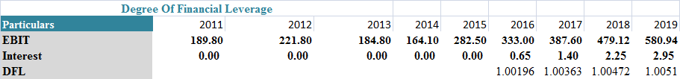

Table: **Financial Risk FANUC**

In the chart we can see that the Degree of financial leverage is positive over the years.When a company has a high DFL; it generally has high interest payments. The high level of interest payments negatively affects EPS. Here in this case the DFL of the company is low. The Lower level of financial leverage gives a massage to the potential investors that the company is not in risky position.

# Ratio Analysis

## Interest Coverage Ratio (TIE)

Interest coverage ratio is calculated by dividing the earnings before interest and tax with the help of interest expense. For FANUC, the highest amount of interest coverage ratio was in 2016.

**Profitability ratios**

Profitability ratios are a class of financial [metrics](http://www.investopedia.com/terms/m/metrics.asp) that are used to assess a business's ability to generate earnings as compared to its expenses and other [relevant costs](http://www.investopedia.com/terms/r/relevantcost.asp) incurred during a specific period of time. For most of these ratios, having a higher value relative to a competitor's ratio or the same ratio from a previous period is indicative that the company is doing well. Here, the ratios are decreasing but very slightly comparing with the previous years to recent years. So, we can say that the company is doing well.

**Debt-Equity ratio:**

Debt/Equity Ratio is a [debt ratio](http://www.investopedia.com/terms/d/debtratio.asp) used to measure a company's financial [leverage](http://www.investopedia.com/terms/l/leverage.asp), calculated by dividing a company’s total [liabilities](http://www.investopedia.com/terms/l/liability.asp) by its [stockholders' equity](http://www.investopedia.com/terms/s/stockholdersequity.asp). The D/E ratio indicates how much [debt](http://www.investopedia.com/terms/d/debt.asp) a company is using to finance its [assets](http://www.investopedia.com/terms/a/asset.asp) relative to the amount of value represented in shareholders’ [equity](http://www.investopedia.com/terms/e/equity.asp).A high debt/equity ratio generally means that a company has been aggressive in financing its growth with debt. Aggressive leveraging practices are often associated with high levels of [risk](http://www.investopedia.com/terms/r/risk.asp). This may result in volatile earnings as a result of the additional [interest](http://www.investopedia.com/terms/i/interest.asp) expense.

Till 2015, the company is a full equity firm. It has no debt outstanding. So debt equity ratio is still 0. And we have make an structure which will give a debt equity ratio of 35%.

# Bankruptcy Risk

Altman’s Z-score

Altman Z score model is a combination of 5 weighted business ratios that is useful to determine the probability of financial distress.

Original z-score component definitions variable definition weighting factor

X1 = Working Capital / Total Assets

X2 = Retained Earnings / Total Assets

X3 = Earnings before Interest and Taxes / Total Assets

X4 = Market Value of Equity / Total Liabilities

X5 = Sales/ Total Assets

According to Z score bankruptcy model:

***Z = 1.2*X1 + 1.4*X2 + 3.3*X3 + 0.6*X4 + 1.0*X5***

To determine the position of the firm in terms of distress following Zones of Discrimination has been in use:

|  |  |
| --- | --- |
| Z Values | Risk Distribution Zone |
| Z > 2.9 | Safe Zone |
| 1.81 < Z < 2.99 | Grey Zone |
| Z < 1.81 | Distress Zone |

There is a possibility that a company will be unable to meet its debt obligations. Bankruptcy risk describes the likelihood that a firm will become insolvent because of its inability to service its debt. A firm can fail financially because of cash flow problems resulting from inadequate sales and high operating expenses. To address the cash flow problems, the firm might increase its short-term borrowings. If the situation does not improve, the firm is at risk of insolvency or bankruptcy.

Bankruptcy risk is incurred because of high use of debt financing. To calculate the bankruptcy risk we have estimated **Altman’s Z score**. If the score is below 1.81 then the firm is facing bankruptcy risk. All of the above calculated score of FANUC are below the benchmark as stated above. So accordingly the firm is not facing the bankruptcy risk apparently. As it is a full equity firm, so bankruptcy is illusive to it. We have shown what will be the scoring position if it uses debt capital for the forecasting years.

**Z score of FANUC*:***



Here, we can see that in all the years the company is in a safe zone where the Z value is greater than 2.99. From 2016 we have suggested to take loan as a result of this Z score has started to decline, and repaying gradually will decrease the debt but asset size will also increase, so we think the score will be good enough.

# Problem Statement

The basic problem of FANUC is to increase its return on equity to the level of comparable companies in the developed world. It has to concentrate on innovation and expansion with the help of its extra cash and taking additional debt. Changing its capital structure to a reasonable level can boost its ROE at a high proportion. The bottom line is that increasing ROE is only possible if the company start using its cash to invest heavily in research and development and fuel expansion through debt to avail cheap WACC which translates into higher ROE in return.

# Valuation Analysis

## Assumptions

Followings are the assumptions behind the estimation of their financial statements:

* As FANUC CORP. is quite old and experienced, the sales growth is estimated to be 20% per year for the next 5 years.
* As per the historical analysis of both of the company, it has been observed that, the average cost of goods sold is 50%.
* The average tax rate for the period is considered to be 30% for the company.
* The terminal growth rate is assumed to be 2% for both of the companies.
* The depreciation is considered to be straight line method for both the company and the percentage is 7.6%.
* Capital expenditure is assumed to be 20% in case of FANUC CORP.

## The WACC calculation

|  |  |
| --- | --- |
| Bond Issue |  |
| Risk Free Rate | 0.005 |
| Market Return | 0.02 |
| Beta | 1.2 |
| Cost of Equity | 0.023 |
| Cost of Debt | 0.005 |
| After Tax cost of debt | 0.0035 |
| Weight ot Debt | 0 |
| Weight of Equity | 1 |
| Total Debt | 0 |
| Total Equity | 1,199.90 |
| Total Value(Debt+ Equity) | 1199.9 |
| Income Tax | 0.3 |
| WACC | 0.023 |

For calculating weighted average cost of capital in case of FANUC CORP. We assumed the risk free rate is .5% which is equivalent to the return of 10 year Japanese government bond. We assumed market return is 2% and beta is given for the selected companies which is 1.2. Then we considered the cost of debt is .50% which is equivalent to return of a 10 year corporate bond invested in an AA grade rating company and finally we got the WACC equals 2.3%. as we have suggested issuing bond in multiple steps we have calculated WACC every time and it is getting lower. We have taken the average of these rates which came as low as 2.06%. this is the rate we used in simulation.

## Valuation of FANUC

As per the assumptions in the above section, the valuation of FANUC CORP. has been done using FCFE method. The result of valuation is –



As we can see, the Equity value is around ¥1103.197 trillion. The value per share is ¥4051.77 which is about 5.24% higher than current stock price of ¥3850per share.

## Simulation Analysis and sensitivity analysis of FANUC

Simulation analysis is used to represent and interpret the characteristics of a model by selecting the abstract of the model to find out the behaviour or characteristics of that model in response to those characteristics. Followings are output of the FANUCs intrinsic value through simulation analysis which is derived by using the crystal ball simulation function:

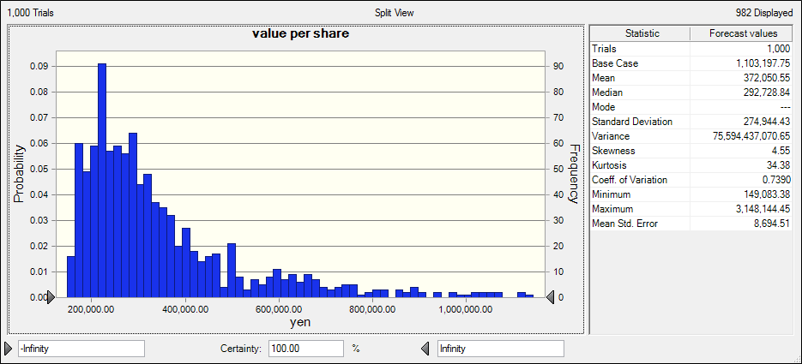 **Figure: FANUC’s Simulation Analysis(bond issue)**

In the above analysis, we see that price of per share is normally distributed. In the statistic section, we can see that the mean value of share is 372050.55and the CV is.7390 which is more than .50. It means that the value per share is volatile. Here skewness is 4.55 which is more than zero. So there is possibility that price will belong within the right tale in the above graph.

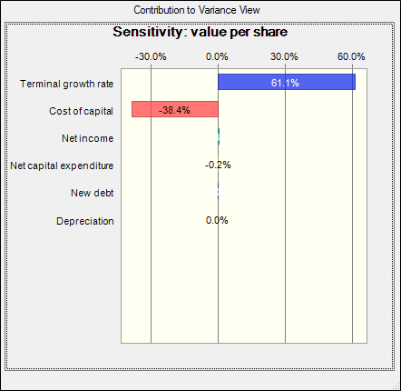

**Figure: FANUC’s Sensitivity Analysis (bond issue)**

Value per share is highly negatively sensitive to the WACC. If WACC is increased by 1%, the value per share is decreased by 38.4%. Value per share is positively sensitive to the terminal growth rate. In fact terminal growth rate dominates the chart. Other factors do not contribute much in either way.

**Simulation analysis of Bank Loan option:**

Bank loan is cheaper than bond given that it gives us less cost of capital. But the corporate governance system of Japan makes it really costly because the lender institution usually takes big role in the corporate governance of the borrower institution. FANUC is a high-tech company. Every piece of information is vital. So, Dr. Y. Inaba’s position on the secrecy of the firm’s strategies seems highly logical. Given this situation, the actual cost of letting outsider’s substantial control in the board can really outweigh the benefits. We have explored the option for further clarity but we do not recommend this though both the value per share and ROE are more favourable in case of bank loan.

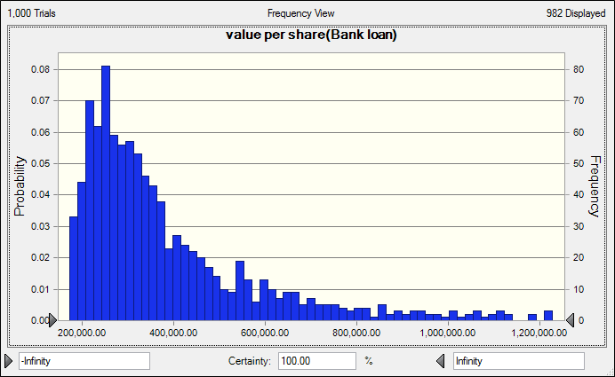

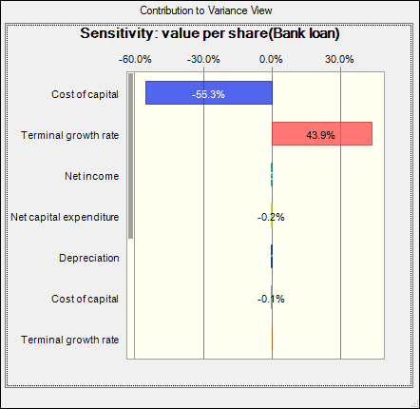

**Figure: FANUC’s Sensitivity Analysis (bank loan)**

**Simulation analysis of convertible bond option:**

If we use convertible bond financing, we get the lowest value per share than other alternatives. As value of the shares of the company is lower than what it should be, people are more likely to convert the bond in shares even at a premium. This will increase no of shares outstanding and hence will bring the ROE down further. So, this cannot be a better choice for FANUC.

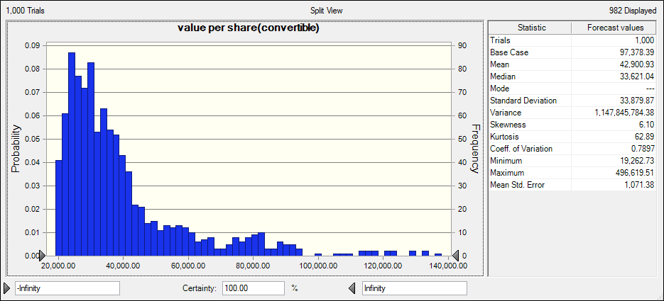

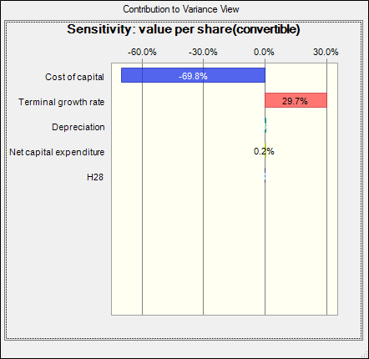

**Figure: FANUC’s Sensitivity Analysis (bank loan)**

**Buyback share with debt financing**

As our analysis shows, share buyback funded by debt can provide us with better ROE. But there are some problems in this method. Firstly, it is time consuming and secondly it will take significantly more than book value which will make a capital loss. And thirdly they have to find the shareholders who are willing to sell their share and it is not so easy task given that the share is already undervalued and in the light of the govt. policy its price will increase in future. And above all buying back shares does not add any value to the bottom line of the company.

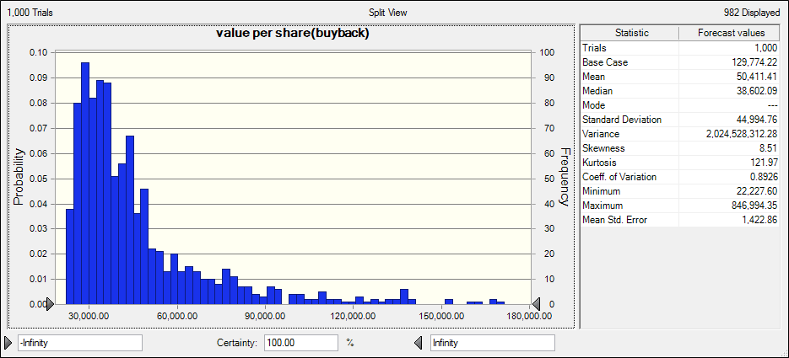

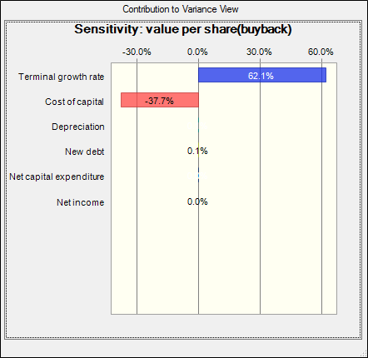

**Figure: FANUC’s Sensitivity Analysis (buy back)**

## Recommendation

In the table bellow, we have shown the resultant ROEs and the Value Per Shares of the alternatives side by side. Obviously bond and bank loans are the dominant ones. Bank loan is cheaper than bond given that it gives us less cost of capital. But the corporate governance system of Japan makes it really costly because the lender institution usually takes big role in the corporate governance of the borrower institution. FANUC is a high-tech company. Every piece of information is vital. So, Dr. Y. Inaba’s position on the secrecy of the firm’s strategies seems highly logical. Given this situation, the actual cost of letting outsider’s substantial control in the board can really outweigh the benefits. We have explored the option for further clarity but we do not recommend this though both the value per share and ROE are more favourable in case of bank loan.

In case of Bond, the company has to sign covenants that may limit a few policy actions of the company in future. But given the strong prospect and already established track record, it is very unlikely that the company will not have sufficient fund to breakthrough those covenants if needed. But more importantly it will give the company enough funds to lever its capital structure without compromising any key board position to an outsider. This is more important than slightly higher cost of capital because for a high-tech company preservation of its strategic information is of supreme significance.

|  |  |  |
| --- | --- | --- |
|  | ROE | VPS |
| Bond | 0.252613 | 546292.543 |
| Bank Loan | 0.251394 | 651508.373 |
| Buy back | 0.174338 | 138284.003 |
| Convertible | 0.085263 | 50636.7634 |

So, in light of our observation, issuing bond is the most favourable option and obviously we recommend issuing long term bond at least 4 times in next four years which will result in debt-equity ratio of 35% and ROE of more than 25% comfortably placing the company alongside its American and west-European peers.

## Conclusion

We have observed that FANUC has possibility of making it to the next level of innovation given its financial and technological superiority. It may be the best Robot maker but it is not duly paying its shareholders. There is enough space to reward the shareholders and aspire for the innovative expansionary programs at the same time. Its large cash reserve, as we feel a misallocation of resources. Also a hundred percent equity capital structure is unnecessary. So, we conclude that the company should restructure by issuing long term bonds in Japanese market which conveniently allows it to avail a very low cost of capital. If the company ensures the proper utilization of its money (both cash and fund from debt), there lies prosperous future ahead.